Running a game
Now, the hardest part, getting games to run. First, run dosbox.exe in your DOSBox folder. Remember that OLDGAMES directory you created in Step 1? You have to basically set that as new directory just for DOSBox. Essentially, it's going to become the C:\> drive of DOSBox. So, type:
Z:\>MOUNT C C:\OLDGAMES
Drive C mounted as local directory C:\OLDGAMES\
To dissect the above:
- MOUNT: Tells the program to mount a directory
- C: Tells the program what you want your new drive to be called (leaving it as C: is fine)
- C:\OLDGAMES: This is the directory I want to set as the new drive for DOSBox, because all my games are in it. If you created a different directory, write in the directory you created.
(Note: If you want to mount a CD-ROM instead of a folder, type this:
Z:\>MOUNT D D:\ -t cdrom
MSCDEX installed.
Drive D is mounted as CDRom D:\
(Note: "cdrom" is case sensitive and must be lowercase!)
In this example, D:\ -T cdrom tells DOSBox that my D:\ drive is a CD-ROM drive, and the first D, tells DOSBox what my new drive name should be called. If you are running your game off a CD-ROM then make sure to use D: in place of C: in the following examples. You can find instructions on how to mount other devices, such as floppy drives, in the mount section).
After you've done this, you will be prompted with a Z:\>. Now, just write what you wanted to call your new DOSBox drive, which as I said above, we called C. To navigate to that newly mounted drive just type in:
Z:\>C:

C:\>
Hopefully, you're all set! Now, it's time to run the game. Previously I had mentioned a game called TESTDRIV in my OLDGAMES folder. I now want DOSBox to go to that folder. So type in:
C:\>CD TESTDRIV

C:\TESTDRIV>
That's it! CD stands for "Change Directory", so you've changed the directory to TESTDRIV. You can find instructions on how to use the Change Directory command, in the CD section of the Commands article.
One more step, running the game! Most games have an EXE file in their directory that you can run. However, some might require a BAT file, or COM file (common in demos and really old games). Most of the time, the file is in the root folder. Please consult the documentation of your game for which file is needed to start the game. In the case of Test Drive, it's TDCGA.EXE. So now, I just type this:
C:\TESTDRIV>TDCGA.EXE
That's it! Here's a picture of all of the commands I've written about in Step 2:
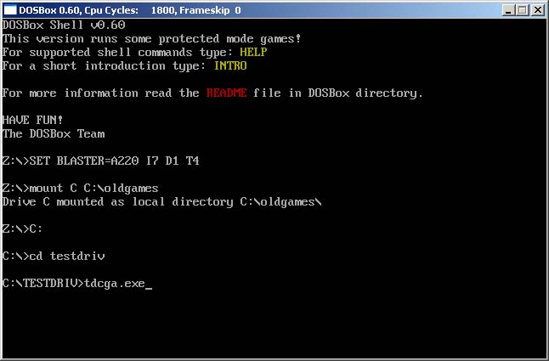

Alternate methods for running a game
The steps described above are closely aligned with how DOS Based operating systems behave natively. However modern operating system allow for more user friendly (although less authentic) ways of playing your favorite games. If the steps above seem tedious or confusing you can try some of these other guides. In most cases these guides will still require you to setup a working DOSBox environment.
- Using Frontends
- Creating desktop shortcuts
  - in Microsoft Windows
  - in Apple OSX
  - in Linux GNOME
NOTE: If you have problems with launching the game, unrecognizable errors being spit out, saving settings, or having the game drop out while running it, one thing to try is to make sure all the files are not set to Read Only. In Windows, select the folder of the game, right click and hit properties, uncheck Read Only if it is checked, and apply to all sub folders.
If you have other errors, please search the forums first before posting a question.

Performance
Yay, you've gotten your game to run! But maybe you're experiencing slowdown? How do you fix this? With the following commands:
CTRL+F7 = Decreases frameskip
CTRL+F8 = Increases Frameskip
CTRL+F11 = Slows down the game
CTRL+F12 = Speeds up the game
Press CTRL+ALT+DEL to open the Task Manager, and click the Performance tab. Start by pressing CTRL+F12 until your CPU Usage level begins to go above 95%. After that, if you still need a performance boost, hit CTRL+F8 to have DOSBox not render some frames. The console window will display all of the changes you've made, and the top of the game window will display the current settings. Adjust these settings as needed until your game goes smoothly. Please keep in mind that not all games will run smoothly on DOSBox.
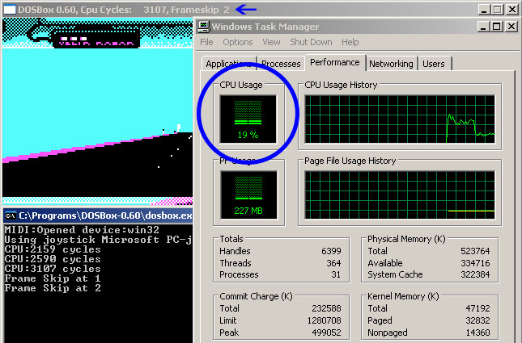

Other Useful features

Quick start
You can save yourself some time by having DOSBox automatically MOUNT your folders and change the drive to C:. In original DOS based operating systems a file called AUTOEXEC.BAT contained any commands that the user wanted executed every time the computer booted up. This functionality is simulated by the [autoexec] section of the dosbox.conf file.
For DOSBox versions older than 0.73 browse into program installation folder and open the dosbox.conf file in any text editor. For version 0.73 go to Start Menu and click on "Configuration" and then "Edit Configuration". Then scroll down to the very end, and add these lines:
MOUNT C C:\OLDGAMES
C:
Now those commands will be executed automatically when starting! If you're having trouble with that, make sure it looks like this (look at the bottom):
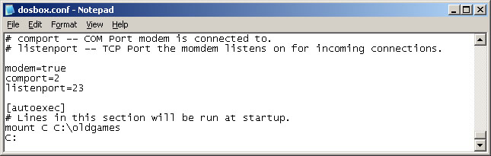

Full Screen
Just press ALT+ENTER to go into and out of full screen.
Alternatively, you can open the dosbox.conf file as mentioned above and change "fullscreen=false" to "fullscreen=true". DOSBox will then run in full screen mode when you open it.
Retrieved from "http://www.dosbox.com/wiki/Basic_Setup_and_Installation_of_DosBox"

